**Machine Learning(10-601) Assignment#5**

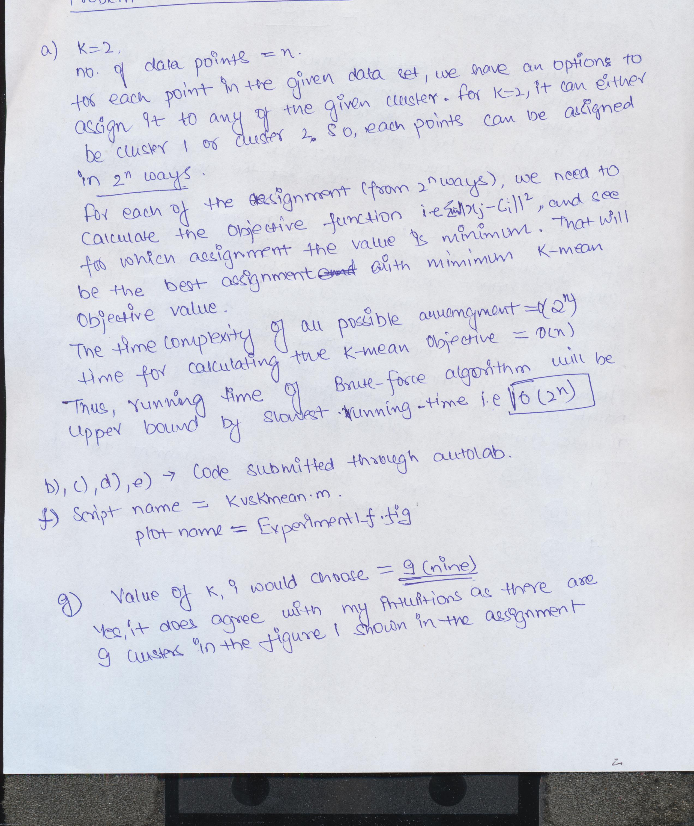

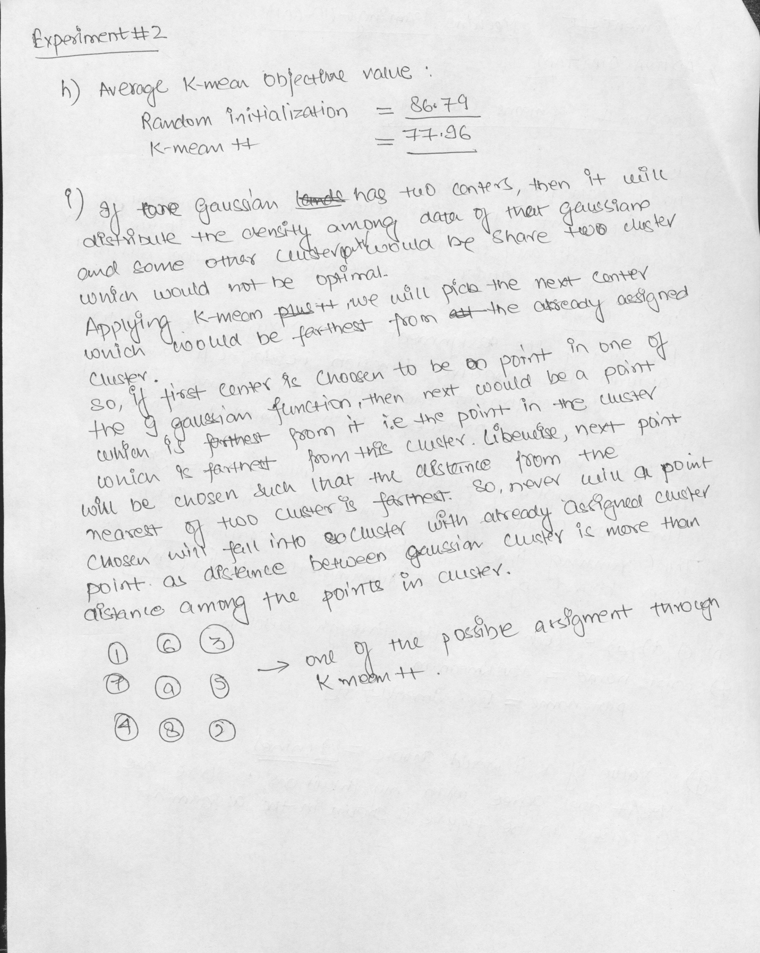

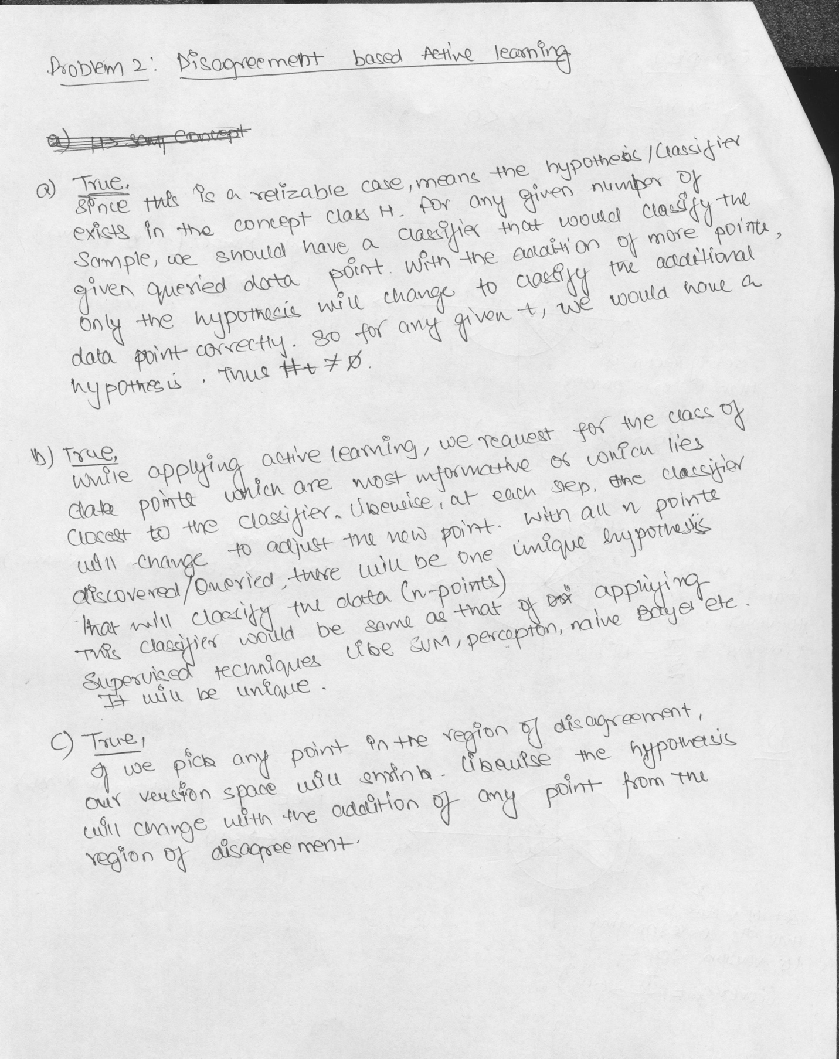

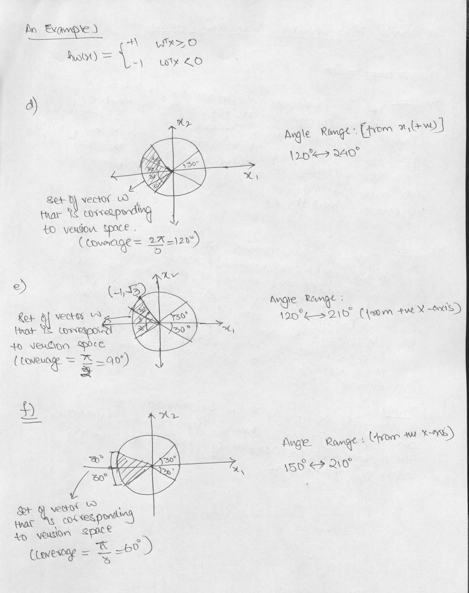

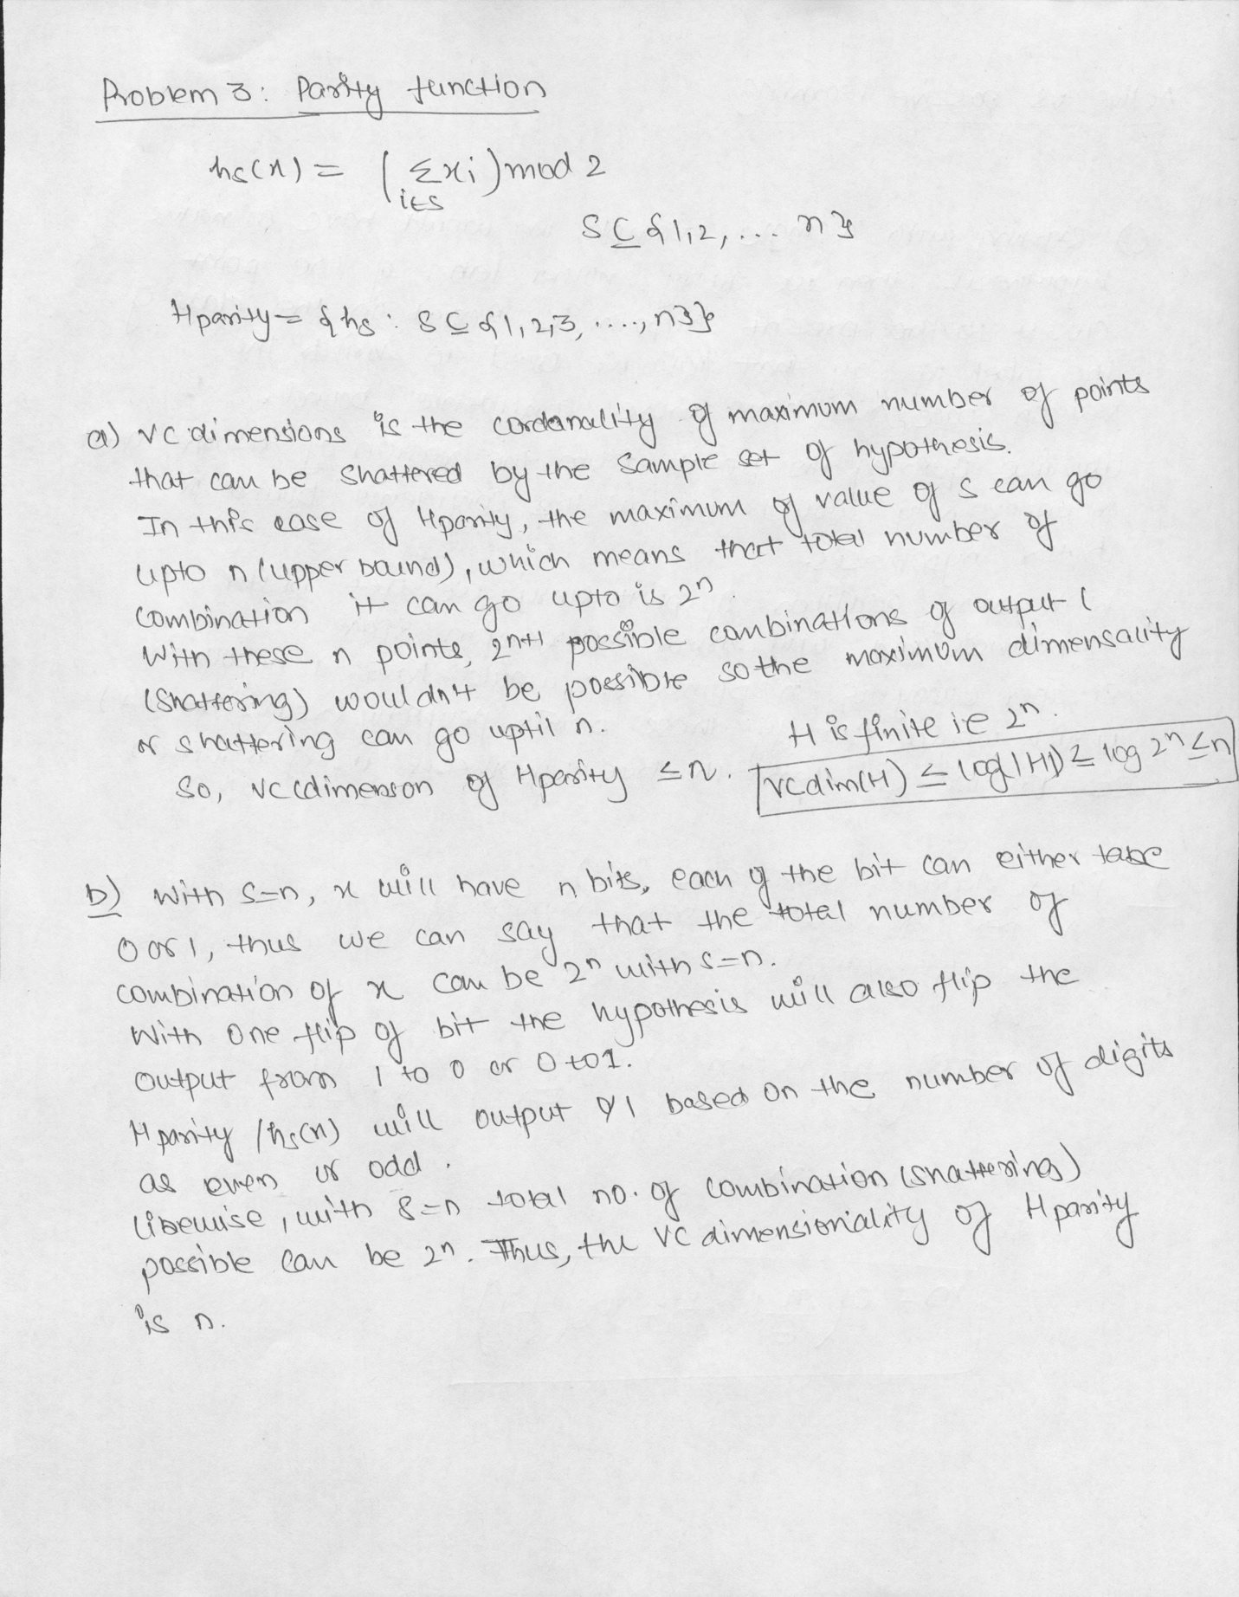

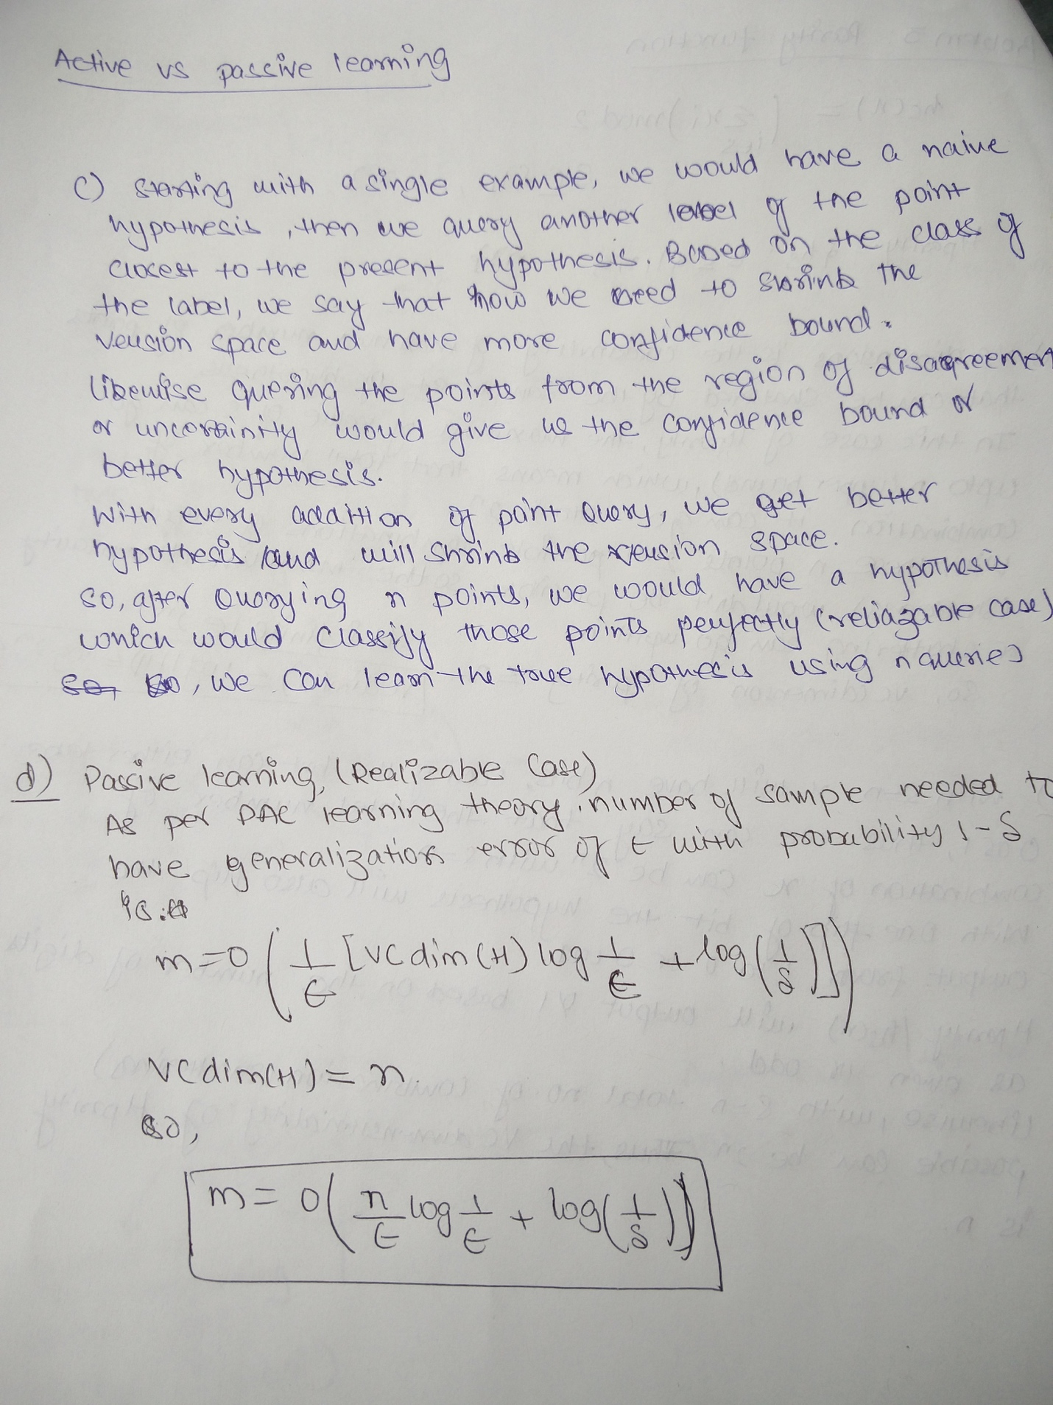

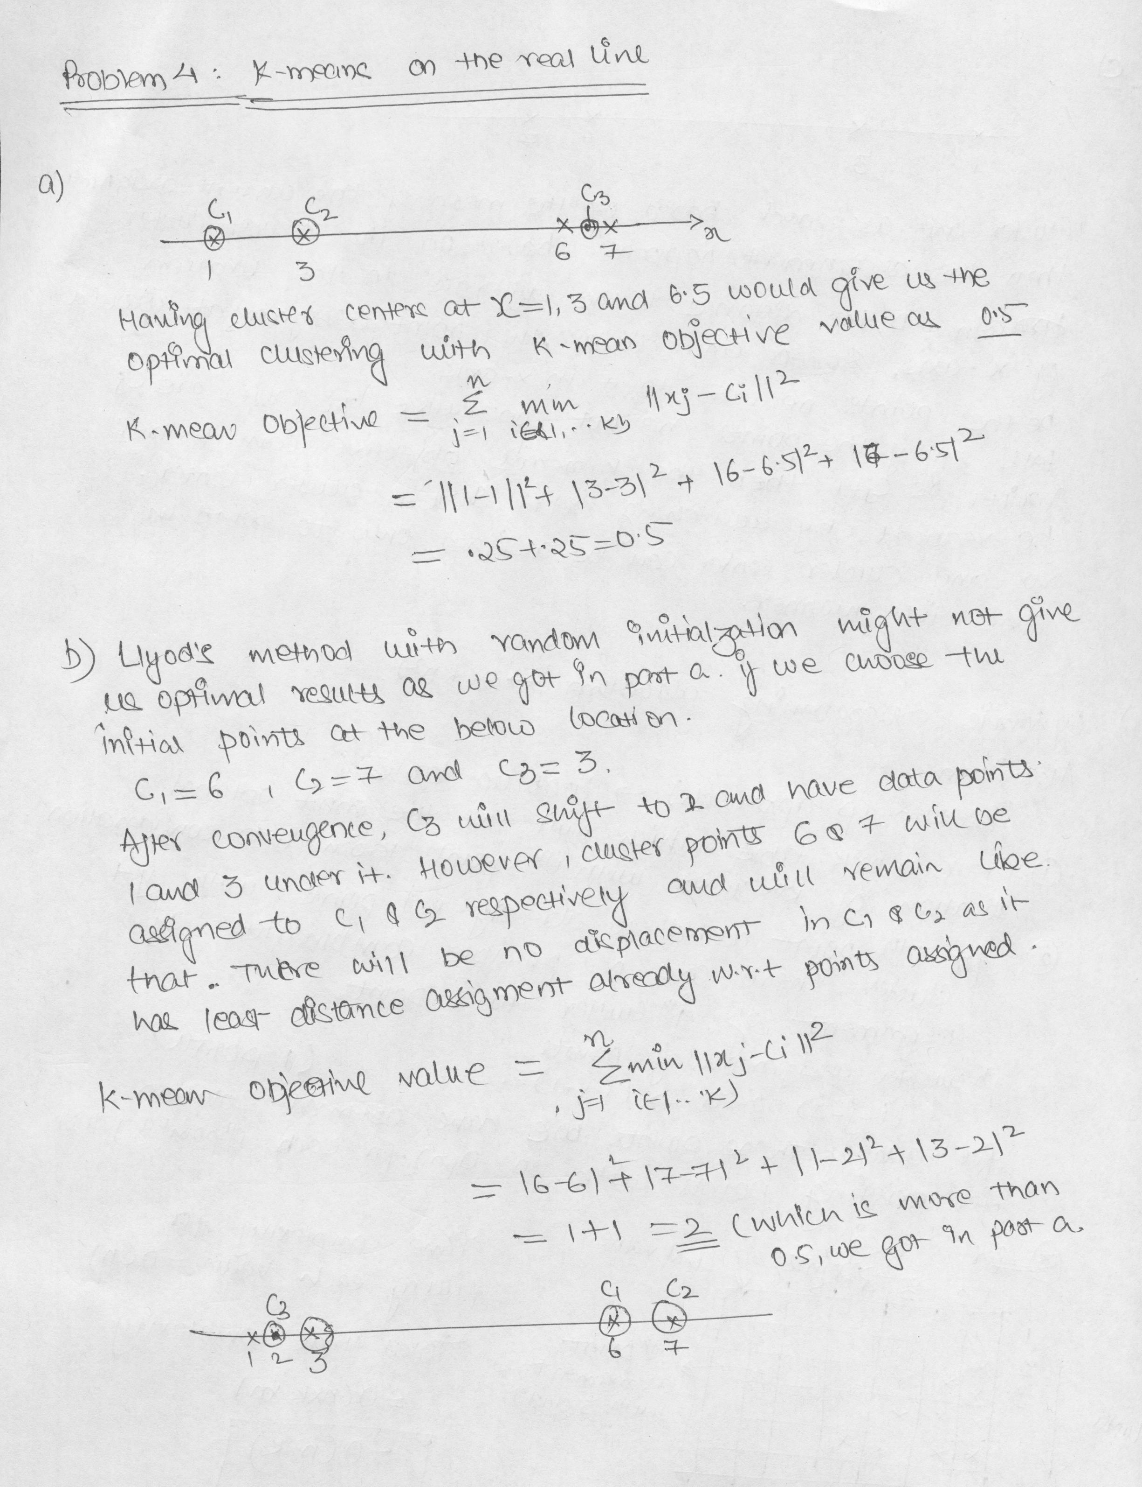

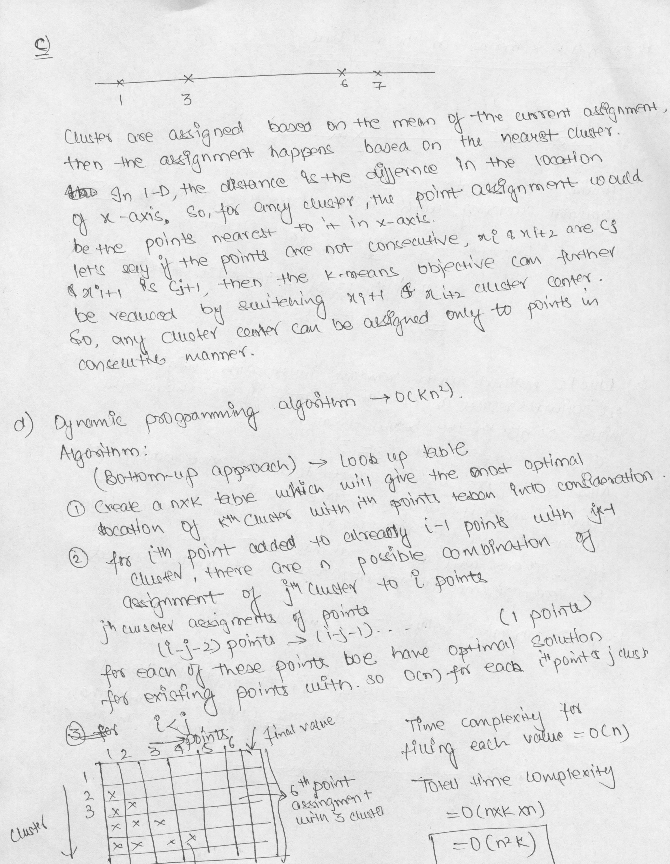

**Experiment#1, Part (f)**

% Experiment#1, Part (f)

function [a]= kvskmean()

obj=0;

load kmeans_data;

[a,b]= size(X);

fprintf('size of x = %d %d \n',a,b);

init = 'random';

num_restarts=10;

obj_val = size(20,1);

for k=1:1:20

[best_C, best_a, best_obj] = kmeans_cluster(X, k, init, num_restarts);

fprintf('k = %d best_obj = %d\n',k,best_obj);

obj_val(k,1) = best_obj;

end

x = linspace(1,1,20);

figure

plot(obj_val);

title('K vs K mean obj value');

xlabel('K (number of clusters)');

ylabel('K mean obj value');

end

**Figure :**

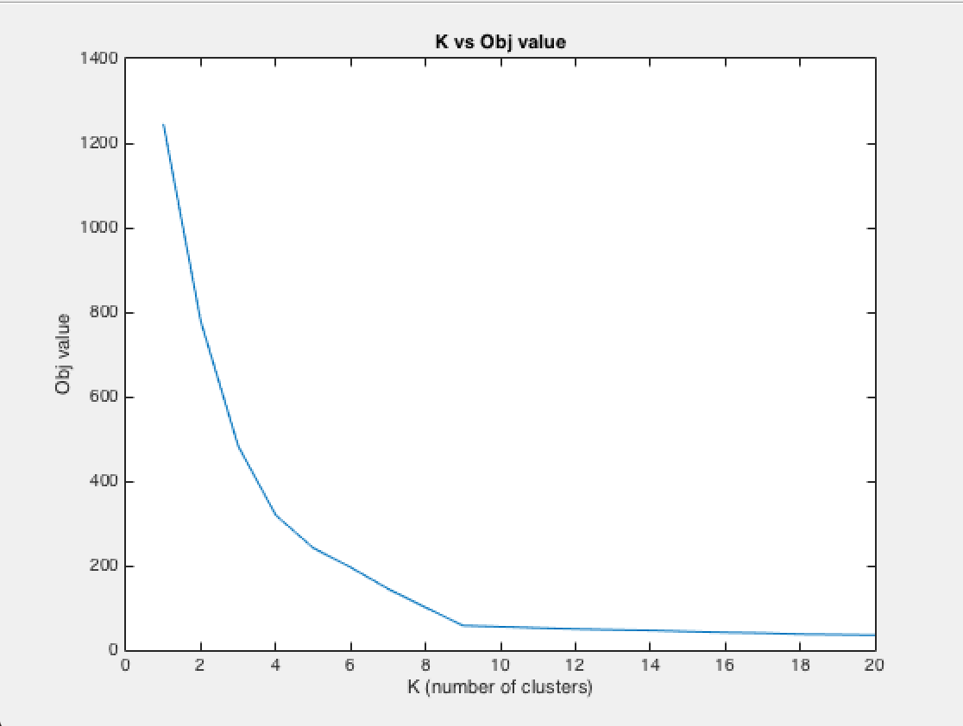

Summary of the work :

1. Implementation and analysis of two new algorithm i.e Brent search and Grid Search
2. Integration of Brent search and Grid search for Linear Mixed Models.
3. Making the algorithm module generic for Models.
4. Addition of L in Linear Mixed models.
5. Other changes in the code like new functions addition for more user defined variables.
6. Been through the test cases of other modules.
7. Starting to write the test cases of GFlasso and LinearMixedModel modules.